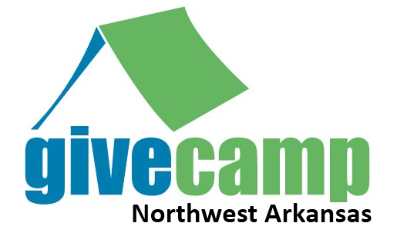

**FOR IMMEDIATE RELEASE**

Northwest Arkansas GiveCamp Brings Free Technology Solutions to Non-Profits during Weekend Event

August 22, 2010 -- Fayetteville, AR – Jay Smith, Northwest Arkansas GiveCamp Chairman, announced today that the Northwest Arkansas .Net user Group in Partnership with the University of Arkansas will be hosting the first annual Northwest Arkansas GiveCamp on January 14-16, 2011.

The Northwest Arkansas GiveCamp is a weekend-long event that brings together local technology professionals to providing non-profits with technical solutions and applications they might not otherwise been able to afford.

The Northwest Arkansas GiveCamp is one of many events of this type that are happening all over the country. This unique event allows technology professionals to use the skills they develop every day to provide applications and services that are in need by non-profits.

The Northwest Arkansas GiveCamp will be held in the University of Arkansas Union Ballroom and surrounding meeting rooms.

Charities and Non-Profits requesting help and volunteers willing to offer their time and skills can submit their application on-line at Northwest Arkansas GiveCamp website located at <http://nwagivecamp.com>.

The press is invited to the event opening to be held on January 14, 2011 at 00 PM where the selected non-profits will introduce themselves and meet their development teams for the first time.

The press is also invited to the event closing where teams will be giving a brief presentation showing the work they have accomplished for each non-profit.

About the Northwest Arkansas .Net User Group  
The Northwest Arkansas .NET User Group is a 501(c)(3) non-profit organization that is dedicated to the promotion, education and adoption of Microsoft .NET Technologies. We strive to provide an environment for professionals to network in Northwest Arkansas to foster the free exchange of ideas and information.

For additional information:

Jay Smith - Northwest Arkansas GiveCamp Chairman   
[jay@jaysmith.us](mailto:jay@jaysmith.us)  
479-422-0122

Matt Garcia - Northwest Arkansas GiveCamp Public Relations Officer  
[mgarcia@gonextconsulting.com](mailto:mgarcia@gonextconsulting.com)  
479-435-0603

*Keywords: Non-Profits, Events, Community, Technology*